**Practical-9**

**Name : Chakalashiya Viraj Pareshbhai**

**Student id : 25TCEJO4**

**Subject : Computer Concepts and Programming**

**INPUT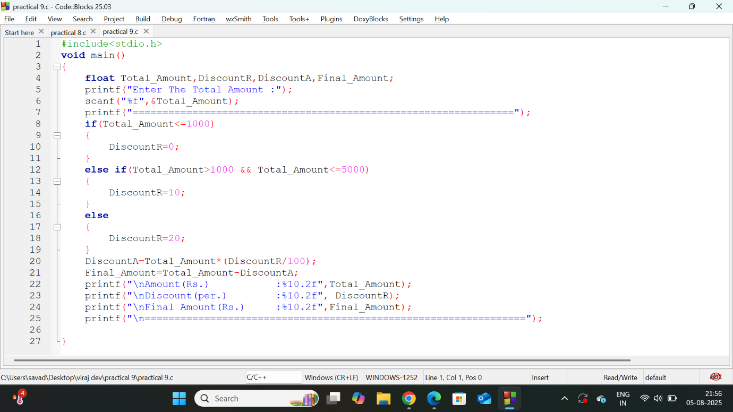OUTPUT**